**Lab Assignment 7**

**(1) Use the rt(n, df) function in r to investigate the t-distribution for n = 100 and df = n − 1 and plot**

**the histogram for the same.**

**CODE:**

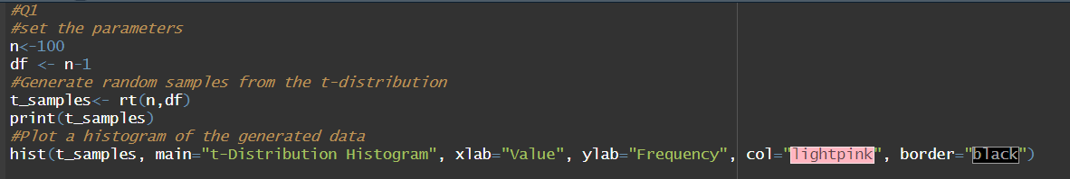

**OUTPUT:**

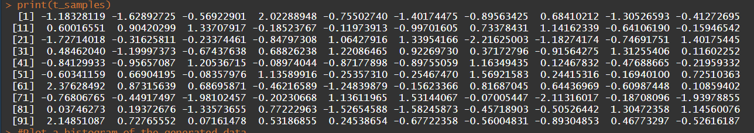

**PLOT:**

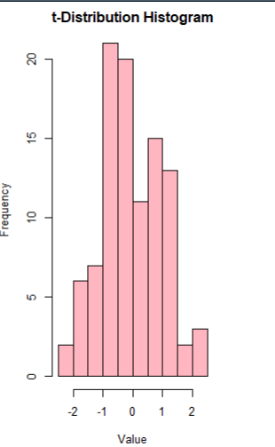

**(2) Use the rchisq(n, df) function in r to investigate the chi-square distribution with n = 100 and**

**df = 2, 10, 25.**

**CODE:**

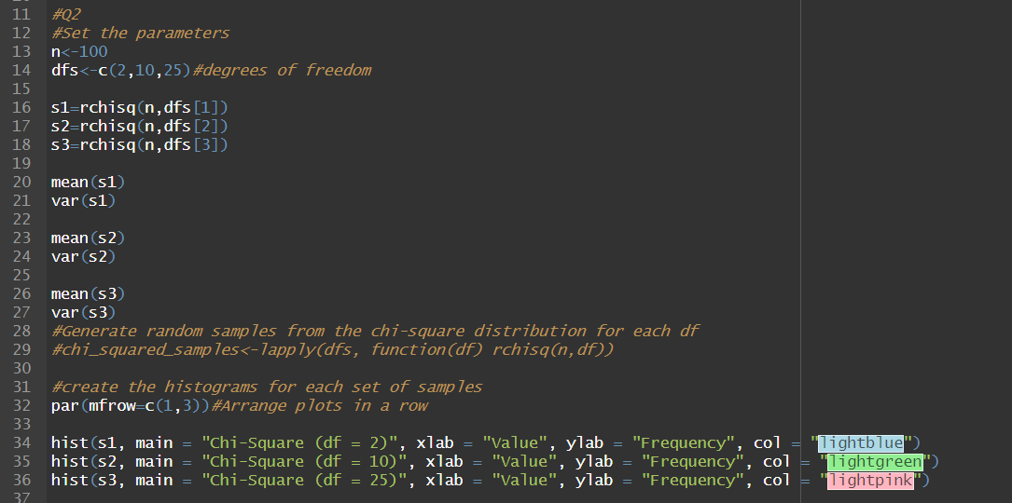

**OUTPUT:**

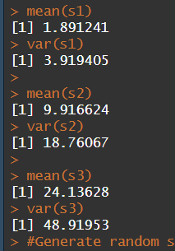

**PLOTS:**

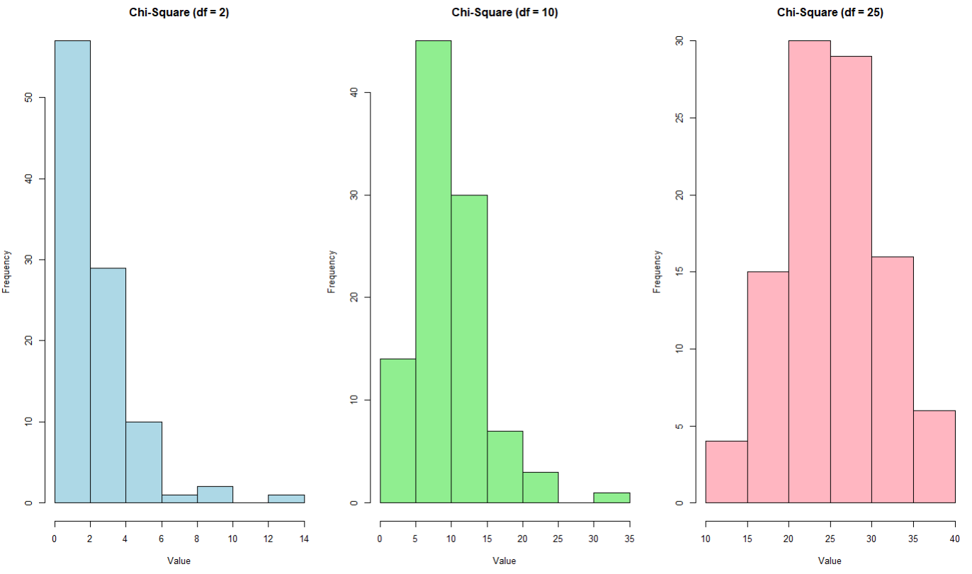

**(3) Generate a vector of 100 values between -6 and 6. Use the dt() function in r to find the values of a t-distribution given a random variable x and degrees of freedom 1,4,10,30. Using these values plot the density function for students t-distribution with degrees of freedom 30. Also shows a comparison of probability density functions having different degrees of freedom (1,4,10,30).**

**CODE:**

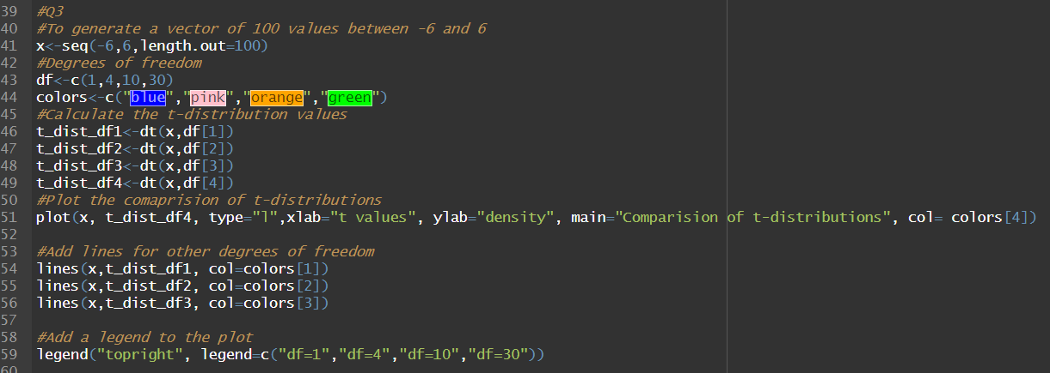

**OUTPUT/PLOT:**

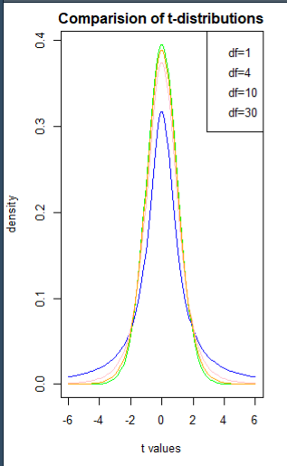

**(4) Write a r-code**

**(i) To find the 95th percentile of the F-distribution with (10, 20) degrees of freedom.**

**(ii) To calculate the area under the curve for the interval [0, 1.5] and the interval [1.5, +∞) of**

**a F-curve with v1 = 10 and v2 = 20 (USE pf()).**

**(iii) To calculate the quantile for a given area (= probability) under the curve for a F-curve**

**with v1 = 10 and v2 = 20 that corresponds to q = 0.25, 0.5, 0.75 and 0.999. (use the qf())**

**(iv) To generate 1000 random values from the F-distribution with v1 = 10 and v2 = 20 (use**

**rf())and plot a histogram.**

**CODE:**

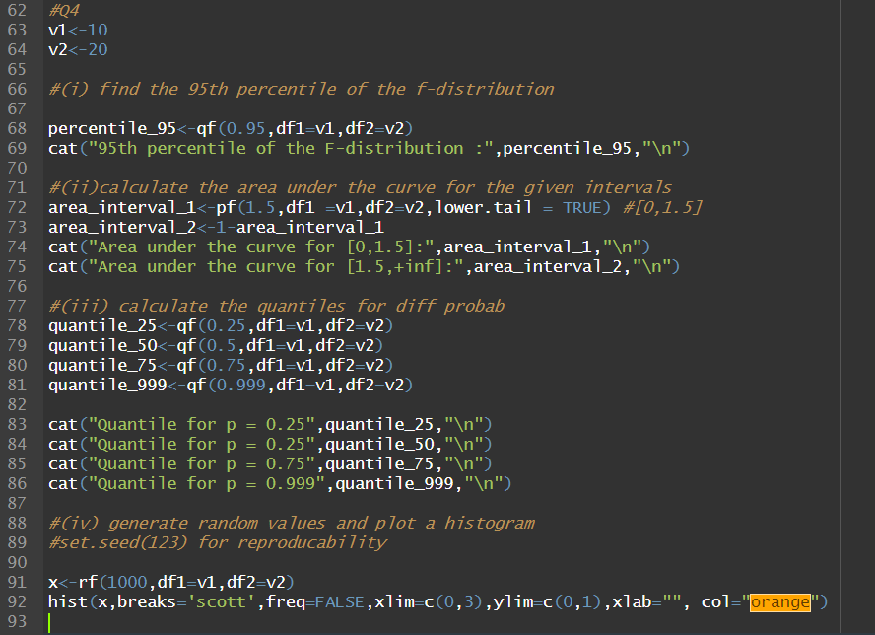

**OUTPUT:**

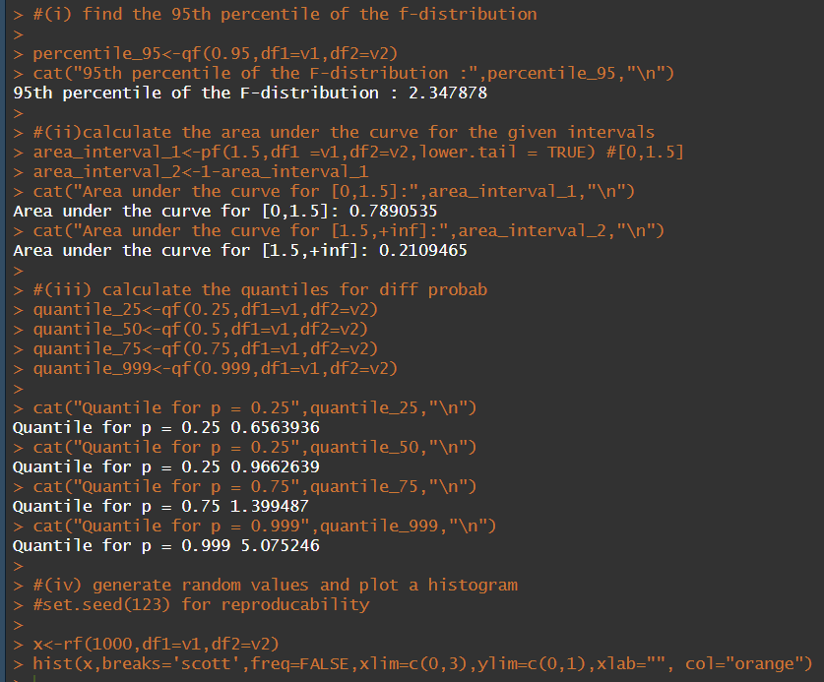

**PLOT:**

